Analysis ReportMental Health In Gamers

short line

Sarah Casauria  
Joanna Sacharz  
Tu Cam Dang  
Ramana Ganesula  
Hien Nguyen

29th March, 2022

# 

# Introduction

The popularity of gaming has increased over many decades, as accessibility, connectivity and affordability through multiple platforms have made it easier for more people to play games than ever before.

From traditional gaming platforms such as consoles, to PCs and now the recent phenomenon of mobile gaming, the popularity and participation in gaming has only increased over time.

Many of today’s games are designed to accommodate people from all walks of life. No longer are games targeting adolescent males but game designers are casting their nets to capture a wider player base by accommodating people of all adult ages, gender and countries of domicile.

As such, the consumption of gaming content has broadened its appeal from its once original purpose of providing household entertainment to that of participation and viewership worldwide.

Over the last decade, we have also seen an increase in mental health awareness. Whether it be related to the societal impacts from the costs of living, the changing composition of the “traditional family” model, the geopolitical landscape or increased education, there is an increased acceptance and reporting of mental health disorders now than ever before.

In 2015, German researchers Marian Sauter and Dejan Draschkow, invited video game players globally to participate in a survey about their gaming habits and their mental health (Sauter & Draschkow, 2017).

In this survey, players were asked a ranged of questions about their gaming habits, in particular:

* Playstyle (e.g. Singleplayer or Multiplayer);
* How many hours they spend gaming per week;
* What is their most played video game;
* Why they play video games;
* What platform they play videogames on (e.g. PC, Console, Mobile/Tablet).

Participants were also asked to complete four different psychological questionnaires that assessed their mental health. The questionnaires used were:

* Generalised Anxiety Disorder scale (GAD-7; Spitzer et al., 2006)
* Satisfaction With Life scale (SWL; Diener et al., 1985)
* Social Phobia Inventory (SPIN; Antony et al., 2006)
* Single Item Narcissism Scale (SINS; Konrath et al., 2014)

# Research Questions

After reading about the data, three research questions arose:

1. On average, how many hours do people spend gaming per week?
2. Is there a correlation between mental health disorders and amount of time spent gaming?
3. Is there a relationship between mental health disorder prevalence and different demographics?

# Analysis Plan

We are using the ***GamingStudy_Data.csv*** file obtained from Kaggle (<https://www.kaggle.com/datasets/divyansh22/online-gaming-anxiety-data>). Based on the research questions developed, our analysis plan is as follows:

* Obtain demographic information for participant population
* Create graphs to describe and analyse population gaming data and mental health questionnaire scores.
* Create heatmaps and choropleth maps to visualise and compare average population data globally.
* Undertake statistical analyses in the form of t-tests, ANOVA, and linear regression to determine any relationships between mental health and gaming habits.

# Study Population

A total of 13464 responses were recorded for this survey. However, for the analyses below, the total survey population was cleaned and any invalid or blank responses were removed from the analysis dataset. The final number of responses for analysis was 11682.

# Mental Health Disorder Global Prevalence

Choropleth maps were created to visually depict the global prevalence of mental health disorders amongst the survey participants. The dataset was grouped by country of residence and the median GAD-7, SWL, and SPIN scores were obtained for each country, and the geographical coordinates for each country were obtained via a Google REST API.

For this analysis, the total survey population was cleaned and any responses without a country of residence entered was removed from the analysis dataset. (N = 11598)

## Survey Participant Distribution

The majority of participants who responded to this survey resided in the United States (n = 4018), followed by Germany (n = 1231) and the United Kingdom (n = 877). Overall, European and North American countries were overrepresented in this cohort.

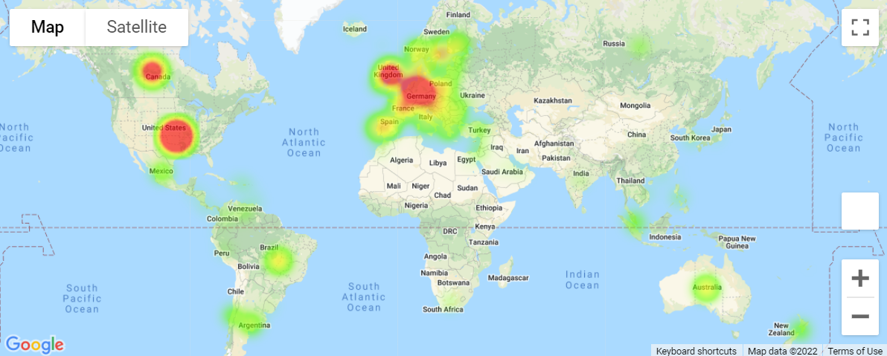

## Global Average GAD Scores

Average GAD scores across countries ranged from 0 to 16, with the majority of average GAD scores (80.3%) correlated to mild anxiety (score between 5-9). South East Asian countries reported the highest average GAD scores.

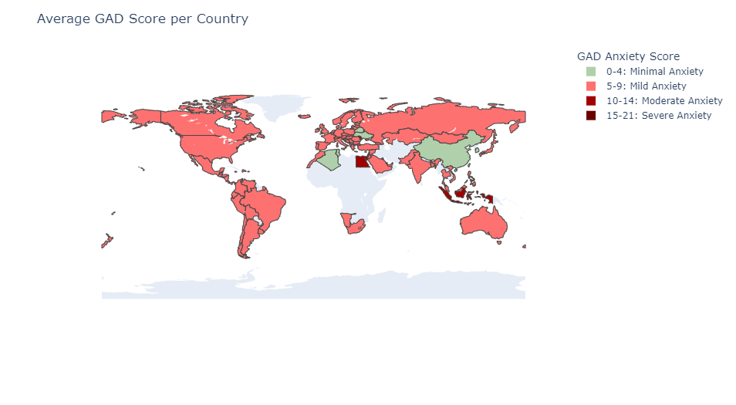

## Global Average SWL Scores

Average SWL scores across countries ranged from 8 to 35. Across the globe, a majority of countries (39.3%) reported slight dissatisfaction with life (score between 15-19). Guadeloupe reported severe dissatisfaction with life with an average score of 8, whilst Namibia reported the highest median satisfaction with life, with a score of 35. However, there was only one respondent from both countries respectively, which will have influenced the analysis.

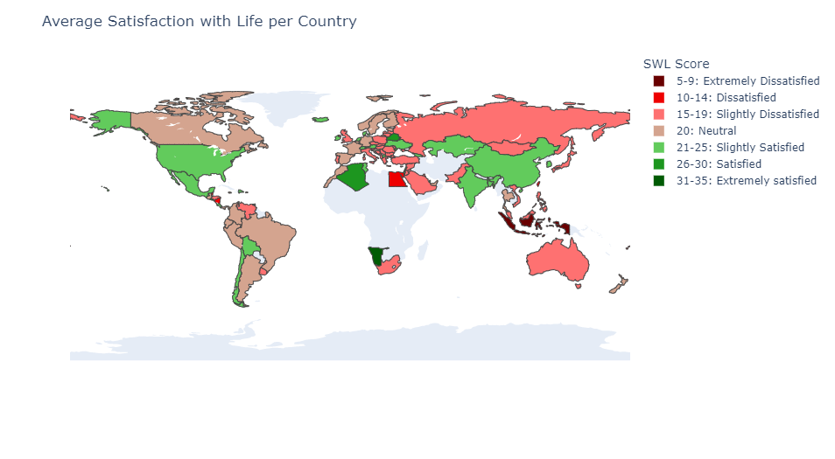

## Global Average SPIN Scores

Average SPIN scores across countries ranged from 0 to 46. Across the globe, there was an equal number of countries who reported SPIN scores correlating to no social phobia and mild social phobia (45.8% each). Namibia reported the lowest social phobia score, whereas Bolivia scored the highest. However, there was only one respondent from both countries respectively, which will have influenced the analysis.

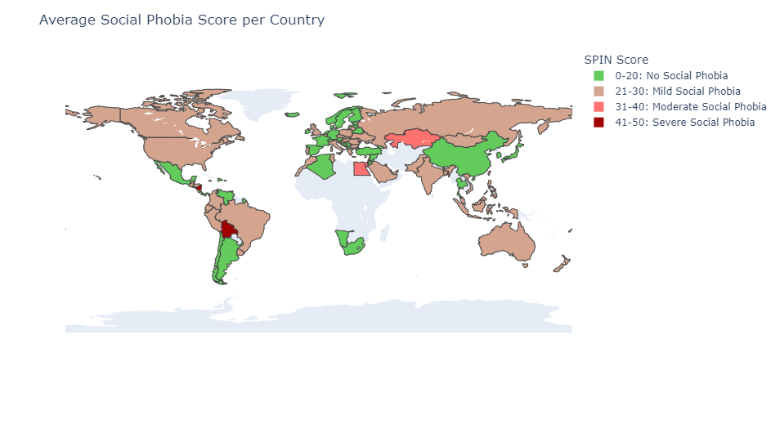

# Relationship between gaming habits and demographics, and time spent playing games

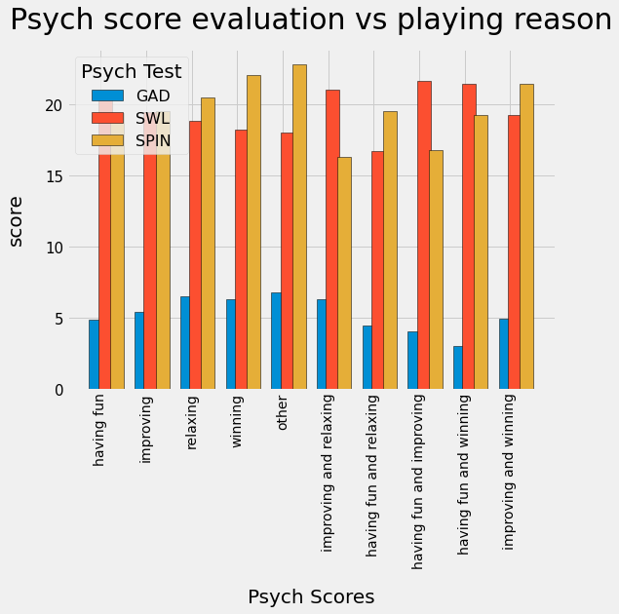

Fig: Psych scores vs reason for playing games

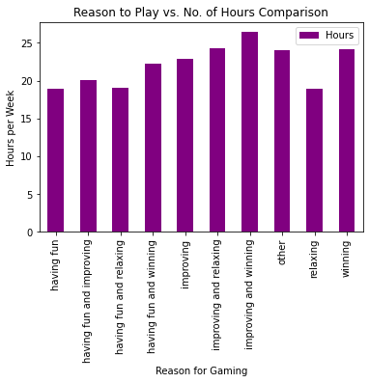

Fig : Reason to Play vs. No. of Hours spent per week

The key options provided during the survey to find out why participants continue to game were:

1. Having Fun (4114)
2. Improving (3728)
3. Winning (1602)
4. Relaxing (530)
5. Other (133)

The responses from these categories make the majority of the input. And comparing the GAD, SWL and SPIN scores for each of these showcases that people who only game to have fun have low GAD, SPIN scores and high SWL scores when compared with the rest. Proving that reason to game plays a key role in how it affects a gamer mentally. This is also directly relatable with the low number of average hours participants from this group (“Having Fun”) game for in comparison with the rest of the group.

ANOVA Test for each of the “whyplay” options:

1. Whyplay and GAD_T : pvalue=2.6976246411633364e-32
2. Whyplay and SWL_T : pvalue=4.486208002292872e-26
3. Whyplay and SPIN_T : pvalue=6.512746496457285e-10

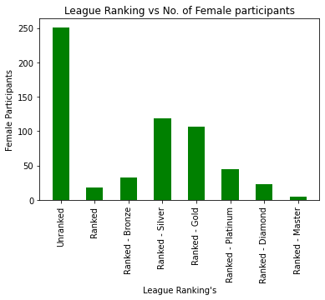

Fig: League Ranking vs. No. of Female participants

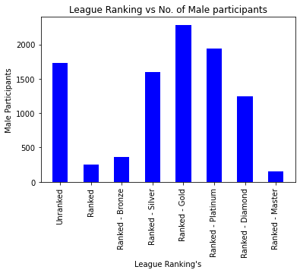

Fig: League Ranking vs. No. of Male Participants

In gender comparison between male and female counterparts with respect to how they trend in a competitive situation we used League ranking to determine the difference. Whilst female gamers have a high ratio of unranked participants in the survey the male gamers were more distributed to the middle level of ranks in silver, gold, and platinum. This shows that there’s a difference in competition levels and there’s more room to analyse on how this would affect gender domination in the gaming industry and how it affects female gamers.

# 

# Investigating time spent playing games and mental health prevalence

The key parameter in this study was the time calculated in hours per week spent on playing computer games. Mental health has been associated with poor time management which could potentially lead to neglectance in so-called: high priority life areas.

## Finding the correlation between time spent on gaming and the outcomes of the survey:

Weekly hours playing computer games vs. GAD outcomes  
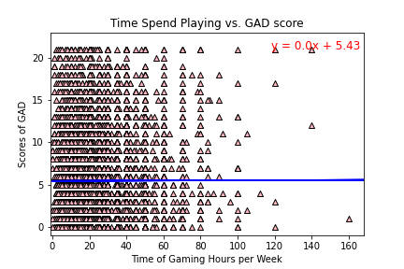

Weekly hours playing computer games vs. SWL outcomes

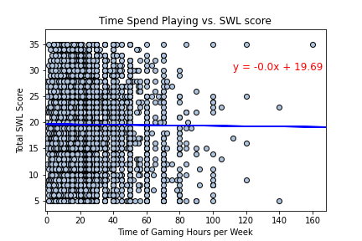

Weekly hours playing computer game vs. SPIN outcomes

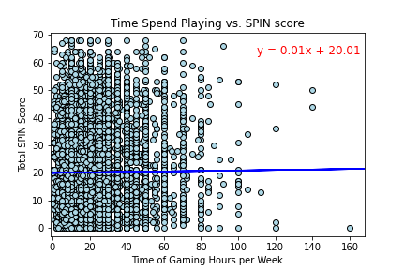

**Conclusion 1**: There was no correlation between the time of playing and reported status of anxiety, satisfaction of life or social phobia (corr.eff <0.4)

## Distributions of mental survey scores classified by time ranges spent on playing computer games:

# 

# 

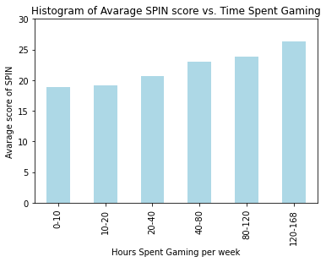

**ANOVA test for respective surveys:**

GAD: p-value = 4.81 * 10-31  
SWL: p- value = 5.89 * 10-42  
SPIN: p-value = 6.4 * 10-22

**Conclusion 2**: There is a trend towards reporting higher levels of anxiety in groups who play more than 80 hours a week. The differences between these groups are significant with p< 0.05 analyzed by ANOVA.

## Gender-dependant scores in GAD, SWL and SPIN:

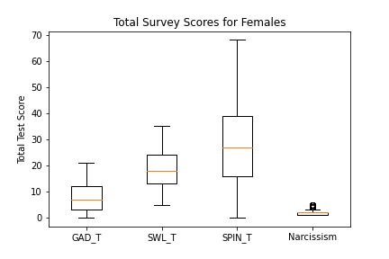

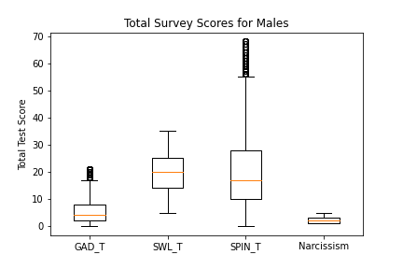

Box Plots showing distributions of survey scores collected for female and male participants. Box -data spread, Orange line - median, circle - outliers.

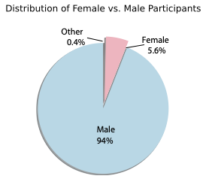

**Two-tail T-test:**

Female vs. Male Time Gaming: p-value = 3.76 * 10-6

Female vs. Male GAD: p-value = 9.98 * 10-28

Female vs. Male SWL: p-value = 0.0099

Female vs. Male SPIN: p-value = 2.08 * 10-39

**Conclusion 3**: There are higher scores of GAD and SPIN reported by women, who represent a significantly smaller group of this study (<6%), women on average play 3 hours less a week than male gamers.

# 

# Relationship between mental health and demographics

According to the above first conclusion, we can see that there is no correlation between the time of playing and reported status of anxiety, satisfaction of life or social phobia.

* + Generalized Anxiety Disorder (**GAD**)
  + Life Satisfaction (**SWL**)
  + Social Phobia Inventory (**SPIN**).

During testing the data, we find that the age groups of gamers have no relationship to the status of anxiety, satisfaction of life or social phobia.

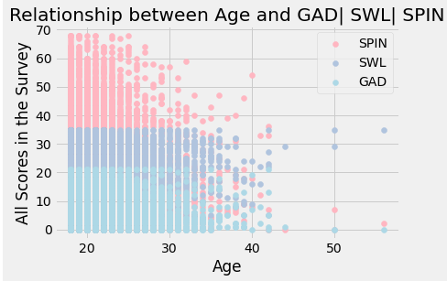

However, we find that the various backgrounds of gamers such as Age, Education and Employment status who have different responses to the different levels of anxiety, satisfaction of life or social phobia. Due to the different scale of score between GAD, SWL and SPIN, there is a difficulty to compare between each category of anxiety, satisfaction of life or social phobia. We mainly focus on which group has the high level of each GAD, SWL and SPIN.

## Comparison between Age Group and GAD | SWL | SPIN

By using the available data, we look at the particular category of Age from 18 to 56 years old and analyze the average of Age group and compare it to GAD, SWL, and SPIN. We have divided Age category into four small groups:

* Teenage from 18 to 19 years old
* Young adult from 20 to 24 years old
* Adult from 25 to 39 years old
* Older Adult from 40 to 56 years old

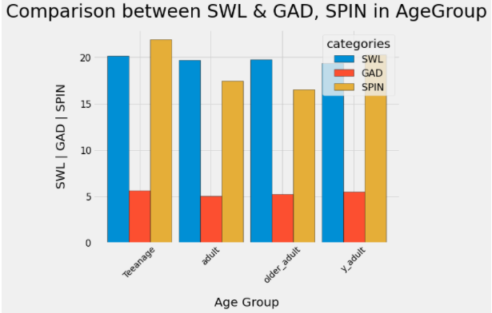

After calculating the average mean of age groups in relation to the GAD, SWL and SPIN. We found that:

Firstly, the analysis demonstrates that the teenage group who is the first group has the highest level of Generalized Anxiety Disorder (GAD) at 5.63, and the lowest group is the adults 5.02.

The next finding of Life Satisfaction (SWL) status is the teenage group who has the highest average at 20.13, and young adult has lowest score at 19.34.

Thirdly, the high level of Social Phobia Inventory (SPIN) is also the teenage group at 21.9 rather than the lowest SPIN is the older adults group at 16.52 points.

In this first comparison, we can conclude that the teenage gamers have the highest level of GAD and SPIN in this survey.

## Comparison between Work Group and GAD | SWL | SPIN

In this stage, we look forward to analyzing our data to identify which group has the high and low level of anxiety, satisfaction of life or social phobia. We have summarized our work status into four categories:

* Employed,
* Student at college/ uni,
* Student at School, and
* Unemployed gamers.

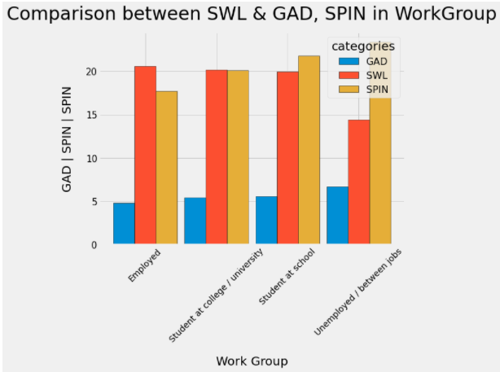

Generally, we find that the ‘Unemployed’ group has the highest level of Generalized Anxiety Disorder (GAD) at 6.68 points, rather than the lowest point is the Employed group around 4.79 points.

Secondly, the average score of Life Satisfaction (SWL) status represents the employed group at the highest point of 20.58 score. The lowest point of SWL is the Unemployed group at 14.38 points.

Finally, the high level of Social Phobia Inventory (SPIN) refers to the Unemployed group at 23.38 points, while the lowest point of SPIN is the employed group at 17.68 score.

This second comparison concludes that the unemployed group or gamers have the highest level of GAD and SPIN while answering the survey.

## Comparison between Education Group and GAD | SWL | SPIN

Our final comparison analyzes the education group in relation to level of anxiety, satisfaction of life or social phobia. By utilizing the database, we concluded that there is give groups of degree i.e.

* Bachelor
* High school diploma
* Master
* None
* Ph.D, Psy.D, MD

We summarize the average of high and low points of the education group, the five groups are calculated in counts and mean format. While performing test and analysis, two groups of bachelor and master degrees cannot be included in the bar graphs.

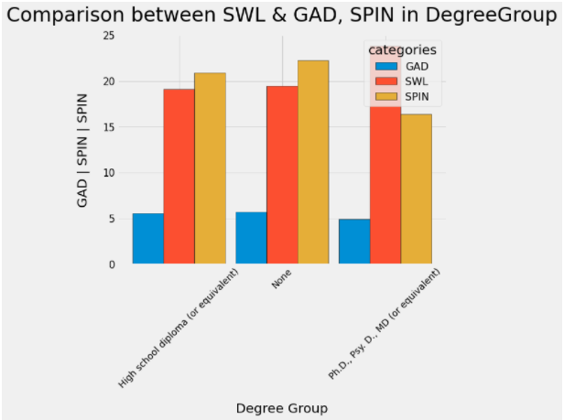

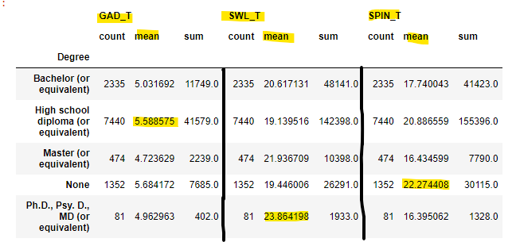

Firstly, the calculation average of Generalized Anxiety Disorder (GAD) refers to the highests level of high school diploma at 5.58 points, while the master has the lowest point of 4.72 points.

Nextly, the highest average calculation of Life Satisfaction (SWL) status is Ph.D, Psy.D, MD at 23.86 points, then the low point of SWL is the high school student.

Finally, the highest average of SPIN group is None - No degree at 22.27 points, the lowest point of SPIN is Ph.D, Psy.D, MD at 16.39 points.

To be concluded in the final comparison, the gamers are from high school diploma and no degree who have the high level of GAD and SPIN.

# References

Antony, M. M., Coons, M. J., McCabe, R. E., Ashbaugh, A., & Swinson, R. P. (2006). Psychometric properties of the social phobia inventory: Further evaluation. Behaviour research and therapy , 44 (8), 1177 - 1185.

Diener, E., Emmons, R. A., Larsen, R. J., & Griffin, S. (1985). The Satisfaction with Life Scale. Journal of Personality Assessment, 49, 71-75.

Konrath, S., Meier, B. P., & Bushman, B. J. (2014). Development and validation of the single item narcissism scale (SINS).

Spitzer, R. L., Kroenke, K., Williams, J. B., & Löwe, B. (2006). A brief measure for assessing generalized anxiety disorder: the GAD - 7. Archives of internal medicine , 166 (10), 1092 - 1097.